**Design Documentation**



In conjunction with



For Team 15

# 

# 

# 

# ABSTRACT

This document is intended to illustrate and clearly explain the design of the system. This includes the Graphical User Interface design, a static model and dynamic model. It is a way the architects and others involved in the project can better understand the purpose and reasoning for the design and how its implementation will work towards the purpose of the system.

**TABLE OF CONTENTS**

**ABSTRACT** **0**

**INTRODUCTION** **2**

**GUI (Graphical User Interface) Design** **2**

**STATIC MODEL** **3**

**DYNAMIC MODEL** **4**

**RATIONAL OF DETAILED DESIGN MODEL** **5**

**TRACEABLE REQUIREMENTS TO DESIGN MODEL** **5**

**EVIDENCE THE DOCUMENT HAS BEEN PLACED UNDER CONFIGURATION MANAGEMENT** **6**

**REFERENCES** **6**

# INTRODUCTION

* This document displays the design aspects of the system in addition to the rationale of the design.
* This document provides a comprehensive design overview of the GUI as well as a number of different design views to depict the static and dynamic aspects of the system. Furthermore, it has traces requirements of the system to the systems design.

# GUI (Graphical User Interface) Design

The interface will be a minimalist intuitive layout for usability and the functionality necessary to fulfill its purpose.

Discovery Button: will launch network discovery and return information about the systems on the network.

Scan Button: will be a vulnerability scan button that initiates the scanning operation on the discovered devices.

Reset Button: will allow one to start a new scan.

Test box: will display the results of the network discover and vulnerability scan

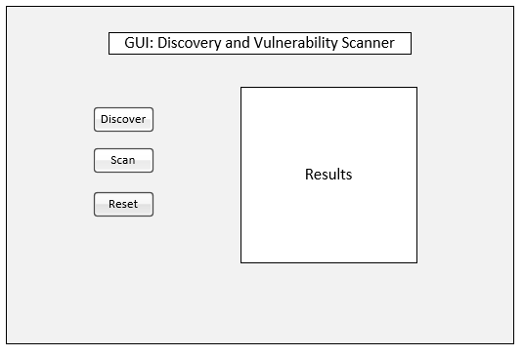

# STATIC MODEL

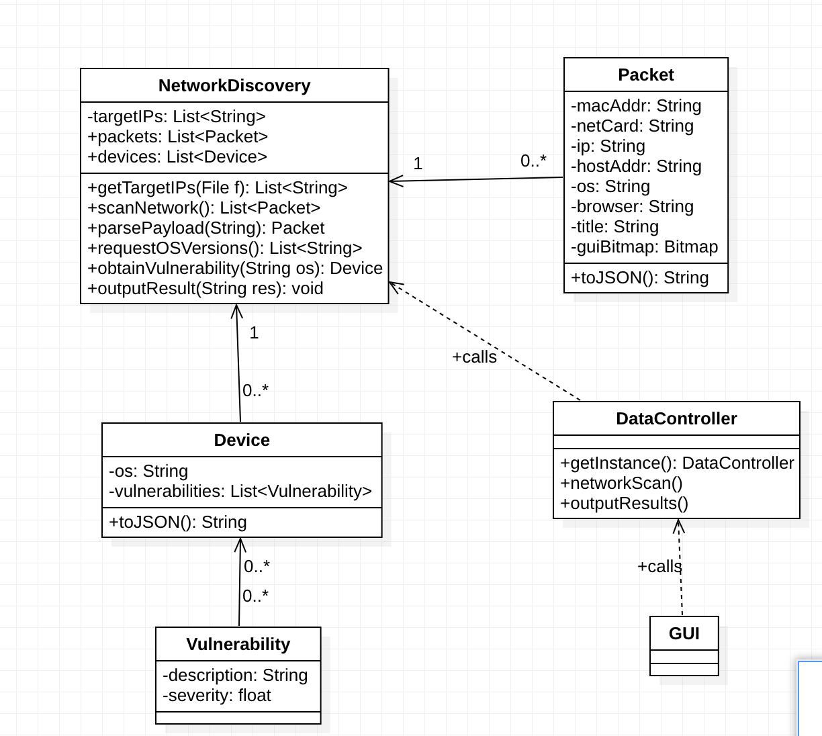

# 

# DYNAMIC MODEL

**Sequence 1: Capture Network Packets, Parse Network Packet Payloads (UC 1 and 2)**

**Non Trivial Steps**

* **System scans network in promiscuous mode for packets**
* **System parses the packet payload to gain further information about the packet**
* **System returns a list of packets gathered**
* 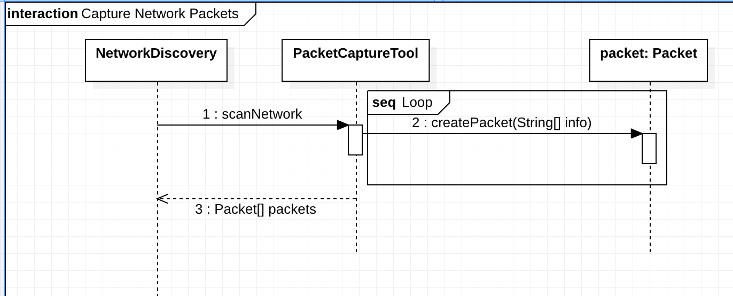

**Sequence 2: Request Operating System Versions (UC 3), Retrieve System Vulnerabilities (UC 4)**

**Non Trivial Steps**

* **System sends an OS request packet to target device IPs**
* **System returns a list of devices, that contains their OS and vulnerabilities**

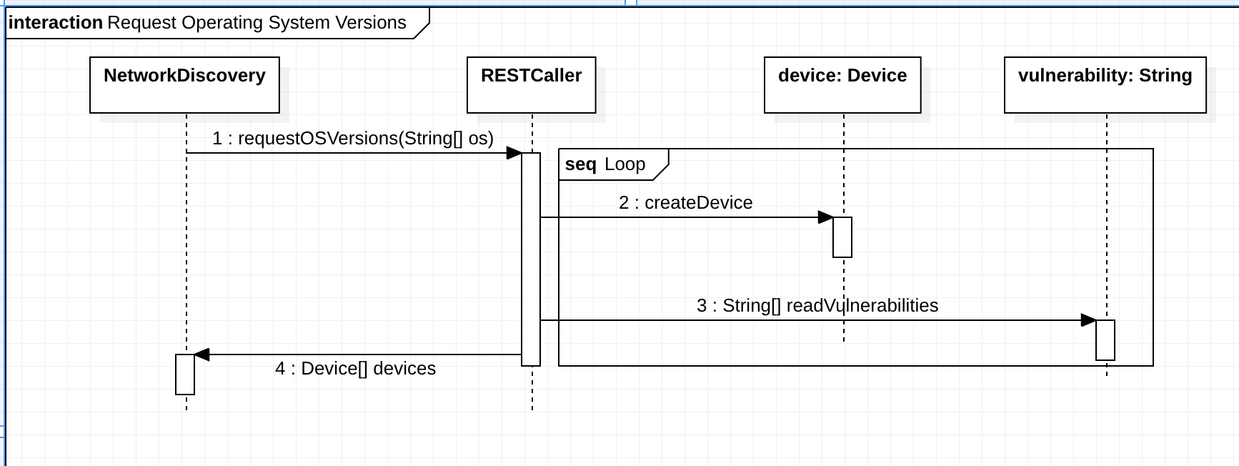

**Sequence 3: Output JSON Formatted File (UC 5)**

**Non Trivial Steps**

* **System calls json function for all packets and devices it has**
* **System uses a file writer to write the JSON files to local storage**
* 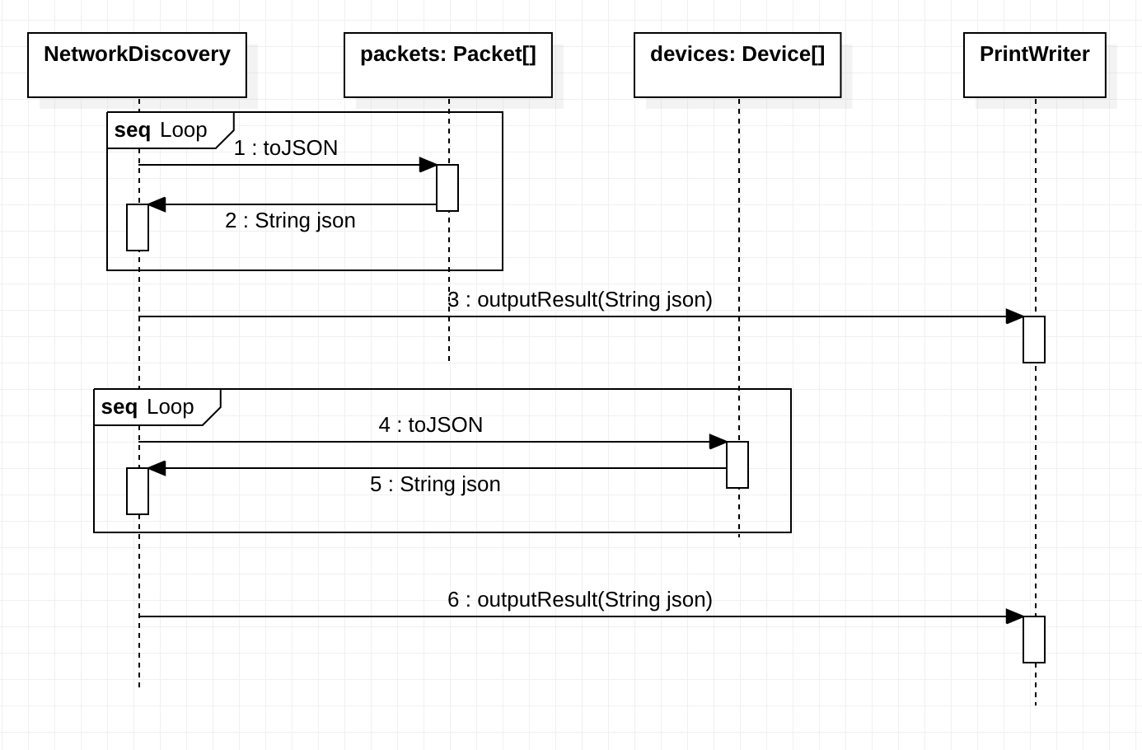

# 

# RATIONAL OF DETAILED DESIGN MODEL

* The design contributes to the systems usability
* This is a functional design.
* This enable customers to scan their network for vulnerabilities with ease.
* This design has high cohesion and low coupling

# TRACEABLE REQUIREMENTS TO DESIGN MODEL

|  |  |
| --- | --- |
| **Requirement** | **Design** |
| Capture Network Packages (UC 1) | Captured in Sequence Diagram 1 |
| Parse Network Packets (UC 2) | Captured in Sequence Diagram 1 |
| Request Operating Systems Version (UC 3) | Captured in Sequence Diagram 2 |
| Retrieve System Vulnerabilities for OS Version (UC 4) | Captured in Sequence Diagram 2 |
| Output JSON Formatted File (UC 5) | Captured in Sequence Diagram 3 |
| Display GUI | Captured in the class diagram with the GUI class |

# **EVIDENCE THE DOCUMENT HAS BEEN PLACED UNDER CONFIGURATION MANAGEMENT**

* Link to the github hosting the document for the team to view: <https://github.com/Narthexes/matilda-senior-design-project/>

# REFERENCES